Skyscrapers

Subject: Physics  Related Subjects: Civil Engineering, Structural Engineering | Grade Level(s): 6-9  Length of Lesson: 75 minutes | Type: Design  Keywords: Structures, Earthquake, Skyscraper, Shape Strength

Lesson Overview
In this lesson, students will expand what they learned about civil engineering when they built bridges, and see how some of the same concepts go into the construction of buildings. They will revisit the strength of various shapes, and be challenged to construct a project that can meet multiple goals.

Lesson Focus
- How will you make your skyscraper? Will you make all the cards into shapes first and then build? Or will you divide your group into shape makers and skyscraper builders?
- How will your skyscraper hold weight?
- How will you test strength as you build without using the actual weights?

Lesson Objective(s) | - Understand how shapes affect a structure’s strength and stability.  - Apply concepts of engineering to build and test a model skyscraper.  - Evaluate and compare different designs based on performance.

Lesson Timing

5 minutes | Introduce the Lesson and mini challenge setup
30 minutes | Mini challenges (height, strength, earthquake
10 minutes | Shape testing and discussion
30 minutes | Final skyscraper design and construction
15 minutes | Testing, data collection, and wrap-up

Materials | - Index cards (100 per group)  - Tape (shared rolls at each table)  - Rulers and meter sticks  - Weights (nuts, bolts, or washers)  - Foam board (1 per group)  - Small paper cups (1 per group)  - Scissors (optional)  - Survey sheets
Instructor Prep | - Prepare building/testing stations and materials.  - Create sample towers or shapes for demonstration.  - Set up a whiteboard or projector for data recording.  - Pre-cut foam board bases if needed.
Related Resources | - Skyscrapers: Engineering Up! - Lesson - TeachEngineering  - Race to the Top! Modeling Skyscrapers - Activity - TeachEngineering

Lesson Plan

Introduction
As more and more people moved to big cities, engineers had to get creative to find space for everyone to live and work. To fit more offices and people into buildings, skyscrapers (very tall buildings) became popular in big cities. To construct these buildings, many challenges have to be met. The buildings must be able to reach tall heights without falling over or collapsing, they must be able to support weight, and (particularly here in Southern California) they must be safe during an earthquake.

Procedure
Part 1: Mini Challenges
Students will begin by building skyscrapers with very specific goals during short mini challenges
- Height challenge – Give each student four index cards and scissors. Put a roll of tape at each table. Give students 2 minutes to build the highest tower they can. The tower must stand on its own and not be taped to the desk. At the end of 2 minutes measure the height of each tower and ask students to observe things that other students did well. Have students look for commonalities among the tallest towers.
- Strength challenge – Give each student 4 new index cards and 5 or 6 weights. Give them 2 minutes to build a tower that can support as much weight as possible. For this challenge, height does not matter. At the end of 2 minutes ask students to report how many weights their towers held, and ask them to look for commonalities between the strongest towers.
- Earthquake challenge – Pass out 4 more cards to each student. Give students 2 minutes to build a tower that can withstand an earthquake (modeled by shaking the desk). The tower cannot be taped to the desk. Height and strength don’t matter. After 2 minutes shake the desks, one group at a time, and see how long each tower will stand.
- Mini challenge discussion – After the 3 mini challenges ask
- Do the tallest towers have the same properties as the strongest towers?
- Do the strongest towers withstand earthquakes the best?
- Do you think you can build a structure that can meet all 3 challenges?

Part 2: Influence of shape on properties
In the second part of the lesson, students will investigate how folding index cards into different shapes will affect their properties
- Ask students if they used any specific shapes in their mini challenge towers. Ask what shapes you could make with an index card. Go over the terms cylinder, rectangular prism, and triangular prism.
- Give each student six index cards. Ask them to make a long and short version of each of the 3 shapes discussed (use one card for each shape).
- Have students test each shape for weight and earthquakes, as they did in the mini challenges. Have students discuss what shapes work the best. Explain that in building skyscrapers, bridges, and other structures, engineers often repeat the same shapes over and over to build up the structure.

Part 3: Build the skyscrapers
- Divide students into 6 teams. Explain that students will use what they have learned so far to build a skyscraper that is tall, strong, and earthquake resistant.
- Give each group a plain sheet of paper. Tell them to fold the paper in half horizontally, then unfold and fold it again vertically, creating 4 sections.
- Explain to students that in this project they will be building skyscrapers that will be judged compared to the other projects in the class. Go over the scoring criteria.
- Give students 10 minutes to brainstorm and sketch 4 different ideas (one in each quadrant of their paper). Ask the students to think about the following questions
- What shapes are you planning to use? Why did you choose those shapes?
- Will you use short shapes, or long shapes, or both?
- Will the tower be the same width as it gets taller, or will you change size as you go up? Why might you want to change width?
- How will you hold the tower together?
- After 10 minutes, have each group choose a favorite idea.
- Give each group a piece of foam board to build on. Students cannot attach the tower to the foam board, but the board will make it easier to transport the tower for testing.
- Give each group a paper cup to attach to the top of their tower. This cup will be used to hold weights during testing.
- Pass out 100 index cards to each group and let the students begin building. Ask them to think about the following things when they build:
- How will you make your skyscraper? Will you make all the cards into shapes first and then build? Or will you divide your group into shape makers and skyscraper builders?
- How will your skyscraper hold weight?
- How will you test strength as you build without using the actual weights?
- After 30 minutes, test the skyscrapers. Start by measuring height with a meter stick. Next, shake the desk 20 times. Finally, place weights in the cup until the skyscraper starts to buckle. Record data on the white board. Once all groups have tested their skyscrapers, rank them and fill out data sheets.

Wrap-up
- Discuss which towers succeeded and why.
- Reinforce how engineers use repeated shapes, strong bases, and flexibility to build safe, tall structures.
- Introduce real-world applications and STEM careers.

Which shape is the strongest (circle one)?
Square Circle Triangle

It is most important for an office building in a crowded city to be:
- Tall
- Strong
- Sturdy and safe
- All of the above

Lesson Background for Teachers
Skyscrapers must manage three primary engineering challenges: height, strength, and resilience. Engineers use knowledge of geometry, material strength, and physics—especially in seismic zones like Southern California—to build safe and efficient tall structures. Understanding how shapes behave under force is critical to civil engineering.

Suggested Real-World STEM Connections
- Civil Engineers design safe and functional buildings.
- Structural Engineers focus on materials and stability.
- Architects blend form and function in tall building design.
Fazlur Rahman Khan
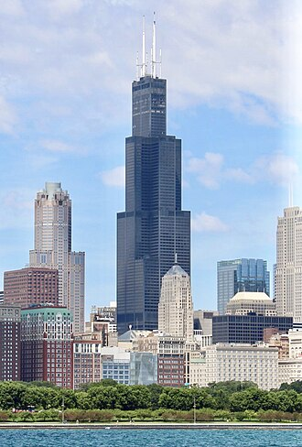
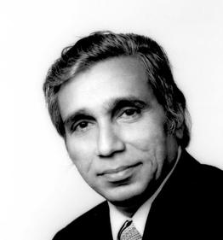
Fazlur Rahman Khan (April 3, 1929 - March 27, 1982) was a Bangladeshi structural engineer and architect, who initiated structural systems that form the basis of tall building construction today. Considered the Father of tubular designs for high-rises, Khan became an icon in both architecture and structural engineering. He is the designer of Willis Tower - the tallest building in the United States (and tallest in the world for many years) and John Hancock Centre, a 100-story tall building.
He also designed structures that are not high rises such as the Hajj Terminal and helped in initiating the widespread usage of computers for structural engineering. Khan, more than any other individual, ushered in a renaissance in skyscraper construction during the second half of the twentieth century and made it possible for people to live and work in "cities in the sky".
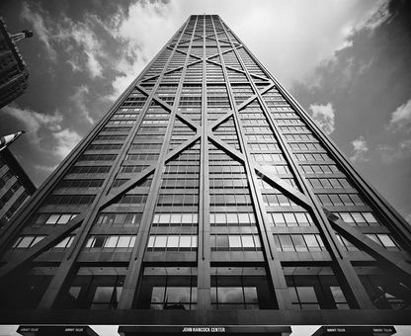
Khan in his short life created a legacy of innovations that is without peer and left an unprecedented and lasting influence on the profession, both nationally and internationally. He has been called the "Einstein of structural engineering" and the Greatest Structural Engineer of the 20th Century for his innovative use of structural systems that remain fundamental to modern skyscraper construction. CTBUH named an award after him called Fazlur Khan Lifetime Achievement Medal. Khan's seminal work of developing tall building structural systems is still used today as a starting point when considering design options for tall buildings.

Lesson Variations and Options
- Add a cost system (cards cost points) to simulate real-world constraints.
- Integrate math by calculating weight supported per card used.
- Introduce wind resistance testing using a fan.

Explanation
Skyscrapers must be carefully designed to stay upright and safe. Engineers use strong shapes like triangles and cylinders, wide bases for balance, and flexible materials to absorb forces like wind or earthquakes. Testing different designs helps engineers figure out what works best in real-life construction.

Key Concepts and Vocabulary
- Stability: The ability to remain upright and resist tipping
- Load: The weight or force a structure must carry
- Structure: A framework built to support or shelter
- Reinforcement: Strengthening a structure using repeated shapes or added support

Safety Notes
- Supervise use of scissors and sharp edges
- Make sure foam board and tape are used responsibly
- Keep weight testing area clear to avoid accidents

